First make sure your Podman desktop is running

Open console and then go tot the local folder “SimpleWeb” in console

--cd SimpleWeb

Now type following command in console

--podman build .

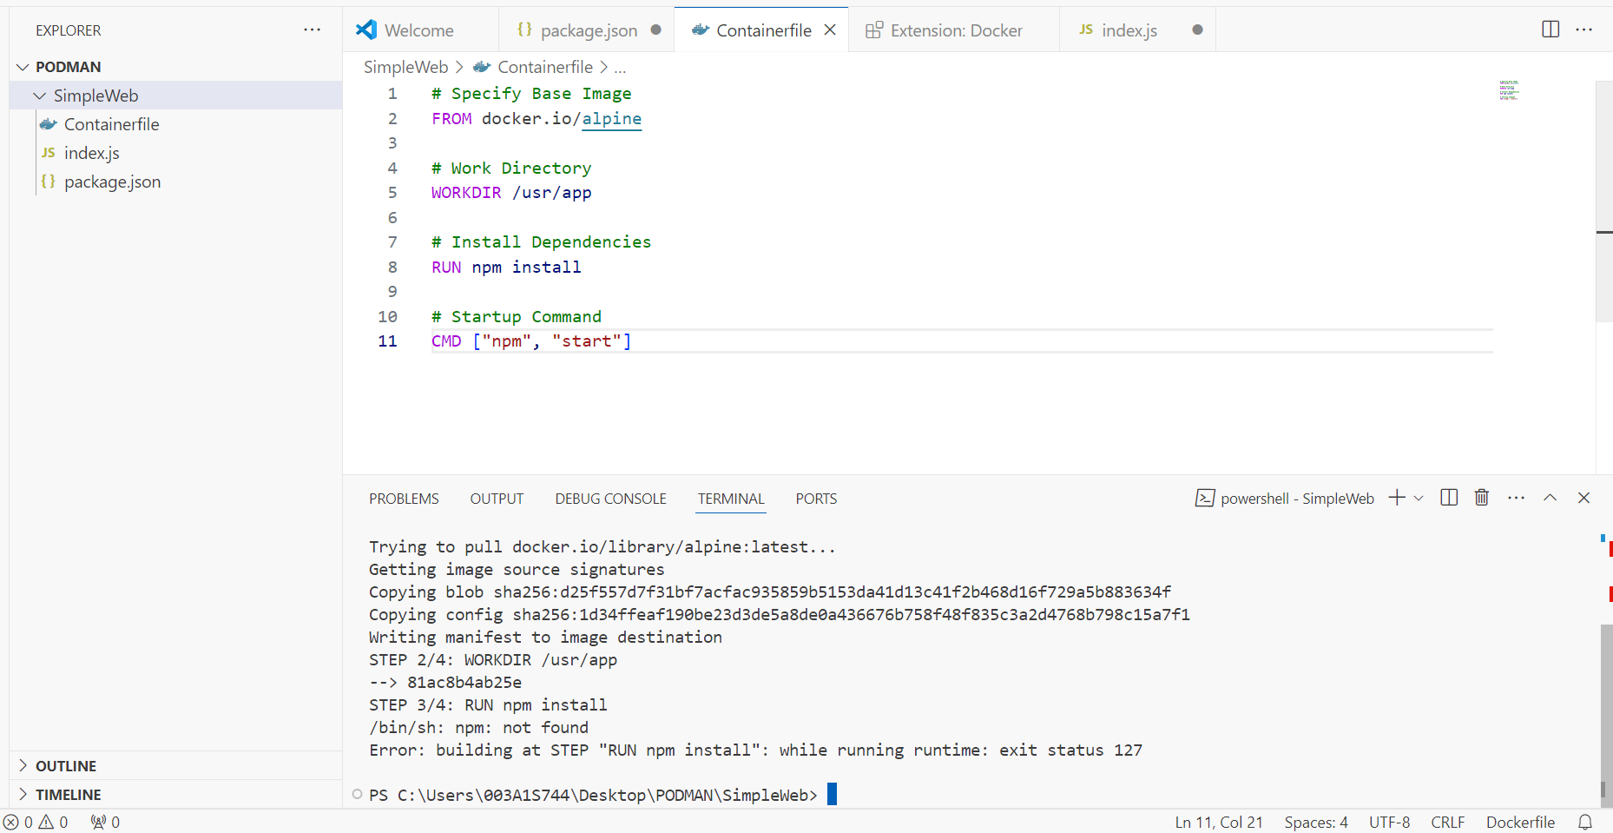

Issue occur saying npm not found

So just change docker image , search from docker hub and change in the containerfile

Replaced the image :

Build is successful after running the following command in console

Podman build .

Now container is build and we have to run it now, before running we need to do tagging for the container image so that we can give name (eg : rubal15/simpleweb ) to it and will call out in further steps

Podman build -t docker.io/rubal15/simpleweb .

-t is we are tagging the container

Now run the below command to see the container listening to the port

podman run rubal15/simpleweb

but when you open “localhost:8080” on browser it will not run , to run to port 8080 run below cmd

podman run -p 8080:8080 rubal15/simpleweb

Now go to podman and see images section and your name will appear in the created image

